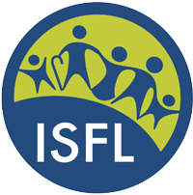INTERNATIONAL SOCIETY OF FAMILY LAW
17th WORLD CONFERENCE
SAVE THE DATE
July 14- 18, 2020.
HILTON BARBADOS RESORT
1st ISFL World Conference in the Caribbean.
………………
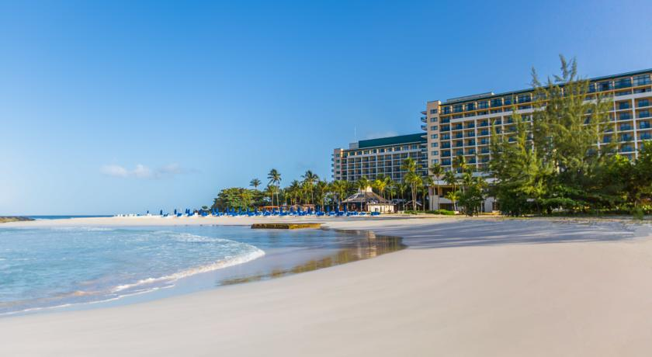
Theme: “Safeguarding the human rights of family members from the womb to the tomb.”
Contact: Hazel Thompson-Ahye, Conference Convenor, at isflworld conference2020@gmail.com

