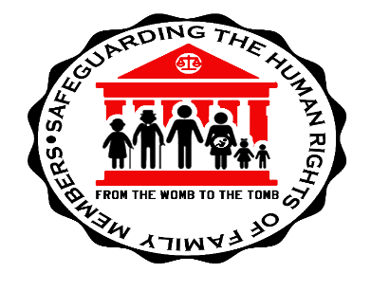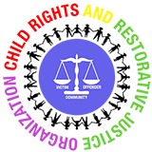

INTERNATIONAL SOCIETY OF FAMILY LAW (ISFL)
CARIBBEAN REGIONAL CONFERENCE
December 13- 16, 2022
Magdalena Grand Golf and Beach Resort, Tobago
Republic of Trinidad and Tobago, West Indies.
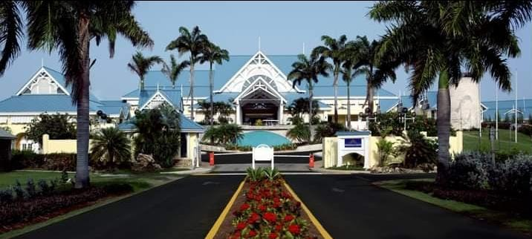
Theme: Safeguarding the Human Rights of Family Members from the Womb to the Tomb.
Presentations by local, regional and international delegates on:
Reproductive rights/ paternity/ custody/ guardianship/ adoption/ foster care/ abduction/ right to identity/ right to be heard/ child justice/ right to access genetic ancestry/ marriage/ divorce/ cohabitation/ non-traditional families/ domestic violence/ property settlement/ elder abuse/ adult guardianship/ rights of persons with disabilities/ rights to inheritance/ freedom of testation/ restorative justice for school misbehaviour, domestic violence and in the prison system and other thought -provoking presentations on cutting edge family law issues.
Contact Senator Hazel Thompson-Ahye, Convener and Vice-President, ISFL at: isflregionalconference2022@gmail.com
For conference and hotel registration, visit our website: https://isflcaribbeanconference.org
N.B. Early registration expires August 31, 2022.
N.B. There are several flights between Trinidad and Tobago daily.

